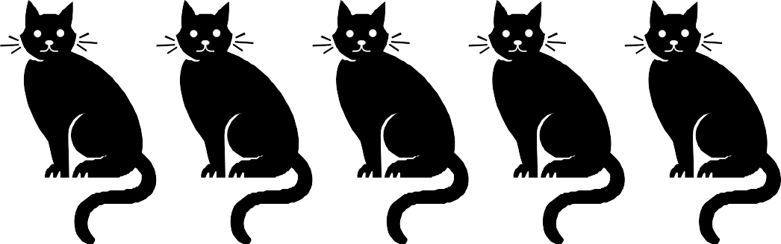

Hello Neighbour

We have experienced disturbance from a roaming cat/s in our neighbourhood and are wondering if the cat/s may be yours?

Description of the cat/s, details of the cat problem and the time that it is occurring:

If the cat/s is yours we would greatly appreciate you considering how you are able to address this issue to prevent any future disturbance.
Information about how to contain cats to a property, manage roaming cats and requirements under the Cat Management Act 2009, can be found on the Kingborough Council website at www.kingborough.tas.gov.au/cats or contact Kingborough Council on (02) 6211 8200.
We are aware that many cat owners do not know that their cats roam and cause disturbance. We do not wish to cause conflict, rather by raising our concerns we hope to achieve the best outcomes for cats, wildlife and the community.

Thank you for your time and consideration.

Your neighbour:

Name:
Address:

Date:

