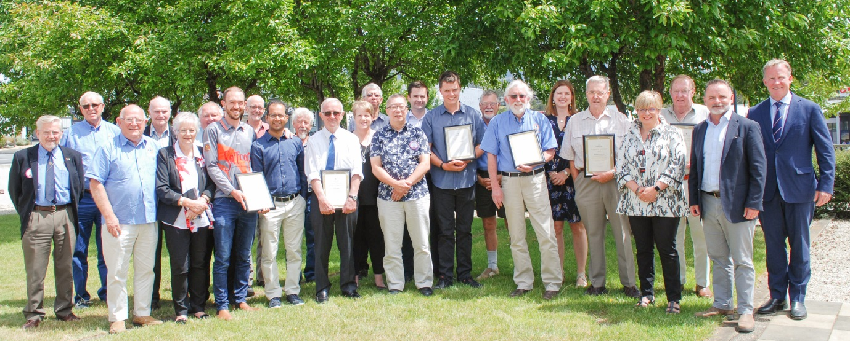
Kingborough Awards Winners 2019
2020 Kingborough Awards
Guidelines and nomination form
Closing date: Monday, 7 October 2019

HOW TO COMPLETE THE FORM
Nominations may be submitted by groups (eg committees, associations etc.), or individuals using the nomination form provided within.
When filling out the nomination form it is important to provide specific examples of how the nominee’s contribution(s) has been outstanding.
Nominations must give clear, adequate and precise details of the person’s/group’s involvements. Please state roles performed by the nominee, outline how their leadership benefited the community and indicate the degree of involvement and examples of their commitment.
The nature of the award places emphasis on what the person/group has done for the community in their various fields of voluntary involvement, rather than recognising achievements as part of normal duties in their paid occupation.
The degree and value of the contribution, as well as the length of service, are the primary criteria.
Awards will be presented by the Mayor at the Kingborough Awards ceremony to be held on Saturday, 11 January 2020.
If you have any questions, or require guidance in the preparation of the nomination form, please call Council’s Community Development Officer on 6211 8170 or email: awards@kingborough.tas.gov.au

The Kingborough Awards are presented annually and recognise outstanding individuals/groups who make a real contribution and difference to our community.
Awards presented are:
- Citizen of the Year
- Young Citizen of the Year
- Community Group of the Year
General Conditions of Entry
- Nominees must be a resident of Kingborough at the time of nomination.
- All nominations must be signed by a nominator in the space provided.
- Citizen of the Year must be 27 years or older as at 6 January 2020.
- Young Citizen of the Year must be aged no older than 27 years as at 6 January 2020.
- All nominations are strictly confidential and the information provided will be used only to assist the Kingborough Council in considering the merits of the nomination.
- Previous recipients of the major awards are not eligible to be nominated for the same award again. However, they may be nominated for a different award.
- Nominees who have previously received a Certificate of Appreciation are eligible to be nominated for the main awards in subsequent years.
- Groups nominated for the Community Group of the Year award should be a group based in Kingborough.
- Self-nomination by individuals or groups will not be accepted.
- Late nominations will not be accepted.
SELECTION CRITERIA
Please refer to the selection criteria and provide as much detail as you can.
SELECTION CRITERIA FOR INDIVIDUALS
Nominees must:
- have made an outstanding contribution to the wellbeing of the Kingborough community (social, environmental, business and/or arts and cultural through leadership and/or personal service),
- display a commitment to community service over a considerable or continuous period of time,
- possess positive and inspiring personal attributes showing qualities such as versatility, flexibility, perseverance in their service to the community, and
- have demonstrated personal effort and initiative that has made a significant difference to the quality of life of the community.

SELECTION CRITERIA FOR GROUPS
Groups must have:
- made an outstanding contribution to the wellbeing of the Kingborough community (social, environmental, business, arts and/or cultural),
- displayed a commitment to community involvement,
- promoted positive activities/qualities for the community,
- produced quality outcomes that have made a significant difference to the quality of life of the Kingborough community.
Final Checklist
Before submitting your nomination, please make sure you have completed the following:
- Addressed the selection criteria
- Completed all sections of the nomination form
- Signed the application
- Attached supporting documentation

For further information please contact Council’s Community Development Officer, Julie Alderfox on (03) 6211 8170 or email awards@kingborough.tas.gov.au

PRIVACY STATEMENT
Completion of this form may require the disclosure of personal information. The intended recipients of this information are officers of the Kingborough council in order to advance the purposes of this form and to carry out Council business. The Personal Information Protection Act 2004 and Council’s Privacy Policy regulate the use of this information, which will not be disclosed to any other party, except with your permission, or if required or authorised by the law. You may make application to access or amend personal information held by Council by contacting the Customer Services Team on (03) 6211 8200. Should you not provide the information sought, Council will not be able to process this application.

NOMINATION FORM
Nominations can also be completed online at www.kingborough.tas.gov.au/awards-ceremonies
NOMINATION CATEGORY
Please tick which category you are nominating for:
Citizen of the Year
Young Citizen of the Year
Community Group of the Year

NOMINEE DETAILS
Title
First Name
Last Name
Organisation/Position
Address
Suburb
Postcode
Telephone | H:  B:  M:
Postal Address (if different from street address)
Email
Date of Birth (Young Citizen of the Year only)

NOMINATOR  Please provide your details. |  | REFEREE  Please provide details of one referee who is available for further information, or attach a letter of support from at least one referee who is able to make direct comment on the contribution and service of the person or group nominated.
Title

First Name

Last Name

Organisation/Position

Address

Suburb

Postcode

Telephone | H:  B:  M:
Postal Address (if different from street address)
Email
Please tell us how you heard about these awards? Newspaper, social media, word of mouth, Council News etc.

ABOUT YOUR NOMINEE
Please use this section to tell us about your nominee - the questions below are a guide to what sort of information we need.
- In what area has your nominee excelled?
- (social, environmental, business, the arts, culture, sports)
- What has been their contribution to Kingborough?
- How have they gone about it?
- What qualities have they displayed?
- How long has their contribution continued?
Please include as much information as possible, you are encouraged to attach extra pages and supporting material.

