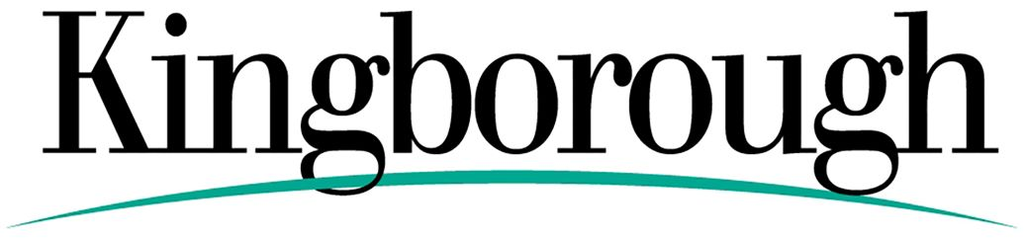
Community Grants Program
Guidelines for applicants
Kingborough Council will consider applications from eligible community organisations for grants of up to $3,000.
The applications must meet the objectives of the Program. The application should:
- Complement Council’s strategic aims.
Strategic Plan available here: Kingborough Council Strategic Plan
- Provide financial assistance to not-for-profit community groups and organisations to develop and implement projects and activities which enhance the well-being of the community;
- Strengthen community capacity and cohesion through capitalising on the strengths and abilities of the community itself to effectively identify its own needs and to plan, develop and implement innovative local solutions;
- Facilitate an equitable distribution of community resources and programs throughout Kingborough;
- Increase participation in and accessibility to a range of quality and innovative programs and activities for the residents of Kingborough.

Eligibility Criteria
The proposed project must:
- Be delivered in the Kingborough municipality;

- Clearly identify and address a community need;
- Show how the community will be involved, both directly and indirectly, in the project; not duplicate existing programs, services or activities in the locality.

The applicant organisation must:
- Be an incorporated not-for-profit organisation, or be auspiced by an incorporated organisation;

Be Kingborough based and should operate within the municipality. Applications for projects from state or national bodies should be submitted by, and be administered by and for the direct benefit of the local branch;
- Be financially viable and able to demonstrate the capacity to successfully manage and administer their proposed project on time and within budget;

- Demonstrate that other support and funding has also been obtained, or is being sought, to support the proposed project. Council will not fund more than 50% of the cost of any project. Other contributions may be financial or in-kind, including voluntary labour and materials; Have appropriate public liability insurance cover.

Note: Council will not fund more than 50% of the cost of any project. Other contributions may be financial or in-kind, including voluntary labour and materials and have appropriate public liability insurance cover.

What may be funded
Examples of what may be funded include:
- Purchase of equipment to support a project or activity;

- Projects and events which contribute to the quality of community life in Kingborough;
- Minor capital works projects (subject to obtaining the relevant approvals and permits);
- Community workshops and seminars or skill development for members of voluntary management committees;
- Newsletters and flyers which promote and encourage involvement in community -based activities.

What will not be funded
- More than one project from any community group per year.
- Any project retrospectively.
- Individuals.
- Ongoing administration and running costs.
- Activities or events which have a fund-raising outcome.
- Trophies or prize money.
- Projects which have the potential to make significant profit, or where other funding sources are considered to be more appropriate.
- Projects which will commit Council to ongoing support.
- The same or similar project more than once.

Assessment and criteria process
Projects deemed eligible for funding will be assessed against the following criteria:
- The organisation being able to demonstrate its capacity to successfully manage and administer its proposed project on time and within budget.
- That there is a sufficient budget and/or resources to deliver the project.
- That the project does not duplicate or overlap with existing activities. • That the organisation can appropriately evaluate the project outcomes.
- That the project responds to a clearly identified need in the community.
- That the project provides quality and innovative outcomes for the residents.
- That the project involves the community, both directly and indirectly, in its development and implementation.
- That the project facilitates greater access and participation by a wide range of Kingborough residents.
- That the project makes sure there is adequate recognition of Council’s support.
- That the project complements Council’s strategic aims. (See Council’s Strategic Plan at www.kingborough.tas.gov.au/strategic-plan )

It is essential that you obtain any necessary building or other permits which are applicable prior to submitting your application. Copies of these should be attached to your application. Where applicable, written quotes must also accompany your application.

Relevant managers will be responsible for determining eligible projects against the assessment criteria. These will then be recommended to the Council for the final decision on which projects will be funded.

The Grants Program and GST
Organisations registered for GST will need to supply Council with a tax invoice.

Funding Agreement Grants made to community organisations will be made on the following conditions:
- Funds must be expended on the project as described in the successful application. Any significant changes to the project must be approved by Council.
- All projects must be completed within 12 months of receiving the funds unless otherwise agreed to by the Council.
- Formal advice of unexpended funds is required and funds not expended for the purpose outline in the application should be returned to Kingborough Council unless agreement has been reached to use these funds for other approved purposes.
- Council is not responsible for any shortfall should the project run over budget.
- Organisations and groups who receive funding must submit a financial statement and completed evaluation report to Council within three months of the completion of the project.
- Wherever possible, acknowledgement should be given to the support provided by Kingborough Council on promotional material for the projects. Copies of such promotional material should be forwarded with the completed evaluation report. Approvals must be sought by the Council’s Communication and Engagement Advisor to the use of Council’s logo to make sure it adheres to brand guidelines.

Applying for a Community Grant
Applications must be made on the Community Grants Application Form.
Completed applications must be saved and either emailed to commgrants@kingborough.tas.gov.au or mailed or delivered to: Community Grants Program Kingborough Council 15 Channel Highway Kingston 7050

Applications are due by 5pm on Monday, 6 September 2021.

We strongly advise that you discuss your proposal with appropriate Council officers prior to completing and submitting your application to make sure you are meeting all the criteria required.

For further information and assistance please contact:
Julie Alderfox, Community Development Officer
T: 6211 8170
E: jalderfox@kingborough.tas.gov.au

