Bee Pattern
Terms:
sl kn: slip knot
ch: chain
sp: space
dc: double crochet
sc: Single crochet
Ch: Chain (daisy chain)
Materials:
Crochet hook 3.5-5
8 ply Acrylic yarn yellow 100 grams, plus some black and white
Stuffing

Wing Directions
Step 1: Slip knot, then daisy chain 8 stitches
Step 2: Turn and then single crochet into end daisy chain stitch
Step 3: Double crochet into second stitch until second last stitch of daisy chain
Step 4: Last stitch single crochet three times around the end of the daisy chain
Step 5: After third single crochet at the bottom of the other side, double crochet until last stitch of daisy chain
Step 6: Repeat from Step 2, increasing amount of double crochet on the second round of the wing, enough to widen.
Step 7: Finish with single crochet and tie off.
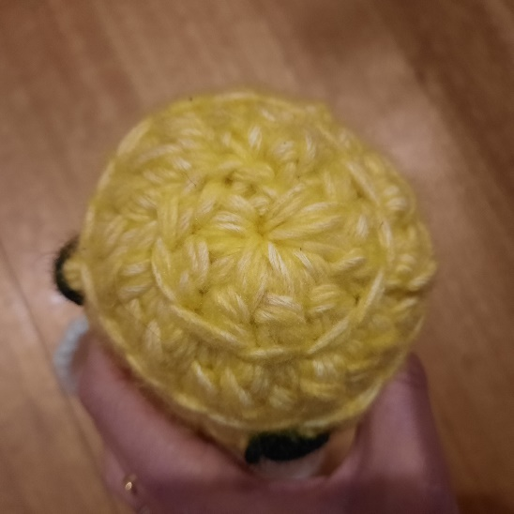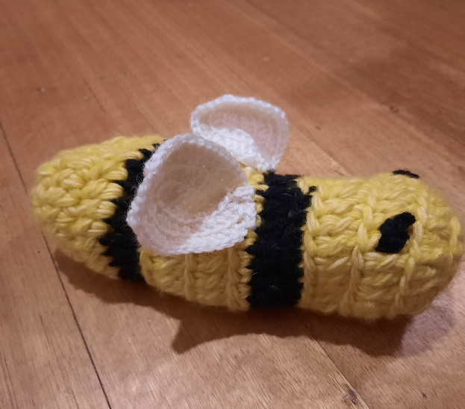
Bee
If you know how to crochet a beanie this is the same principal. Start with the magic circle and expand in a spiral using dc stitches into every stitch. Do two dc into each stitch until you have the desired size then one dc into each dropping down to one Dc into every second one in the last couple of rows. Dc a few rows until the desired length then change colour to black for two rows, change back to yellow, repeat then change to black, repeat back to yellow until bee is long enough then drop down until almost closed up. Stuff with chosen stuffing and close. Finish by attching wings and sewing some black stitches for eyes.

